Get the Facts Right about Overheating in Credit Markets
By Hans Centena
19 June 2013

Four years after the global market economy recovered from the financial crisis, market participants and policy makers raised concern that the corporate bond market had entered troubled waters. This concern has recently resurfaced following the sell-off in US Treasuries and the increase in corporate bond spreads. Many observers of credit markets are worried that the search for yield motives may have lessened lending standards in capital markets, strained the debt capacity of corporations and caused balance sheet fundamentals to weaken. Another worry is that the unusual combination of low yields and tight spreads leaves corporate bond investors with too little compensation for default and rates risks. These concerns create on overheat in credit markets. Therefore, there is need to assess these concerns to get the facts right.

Pockets of overheating in the credit market
Well, there are some pockets of overheating in credit but the fact is most of the risk is concentrated in the low end of the high yield market. One notable pocket of overheating is the loosening of lending standards even worse than they did during the pre-crisis years. The cov-lite loan issuance is very close to the peak of 2007 and the rating distribution of the new issue market is slanted towards low quality issuers. Another pocket of overheating falls on the valuation side whereby the search for yield has eroded the premium set in the low-end of the high yield market. There has been spread widening recently, but still the credit risk premium in CCC bonds offers a meager compensation for default losses. A simple test of current spreads compared to the historical distribution indicates that the CCC bonds are the only assessment bucket trading below its pre pre-crisis median.
Apart from these pockets of overheating, some of the most habitually encountered worries are misplaced. Key among these is the view that record issuance volumes over the past few years have weakened balance sheets. Looking closer at the use of proceeds in the high yield bond and leveraged loan markets shows that refinancing is the main drive for issuance. From this, we see that corporates continue to benefit from the current low yield environment by pushing maturities forward and decreasing debt service. This trend contrast sharply with pre-crisis period where majority of the new issue market served to fund leveraging activities like LBOs, dividends and share buybacks.
Looking at balance sheet fundamentals, the peak in credit card quality that happened in the second half of 2011 has been preceded by a rather slow deterioration. Gross leverage has been significantly rising since mid-2011 but net leverage, which accounts high level of cash on corporate balance sheets, is still low by standards of the past three decades.
The fear of a corporate bond fire sale is a misplaced concern. The fear that a prolonged period of mutual fund could cause outflows. Even when the corporate bond market experience extended period of outflows, the risk of a fire sale similar to that of 2008 is rather small. The risk of a fire sale is lessened by the dramatic post-crisis decline in financial leverage and the very low reliance on short-term funding by banks.
We see that the pockets of overheating in the low-end of the high yield market heightens our negative view on the CCC bonds. Investors remain comfortable with their investment themes. Leveraging is definitely the top risk this year. Even though there has been rates sell-off, yields still remain low and the inflation outlook remains benign. This is a significant risk for potential investors even if it encourages companies to increase their balance sheet leverage.

This chart shows the cov-lite volumes are back to pre-crisis levels and credit quality has weakened.
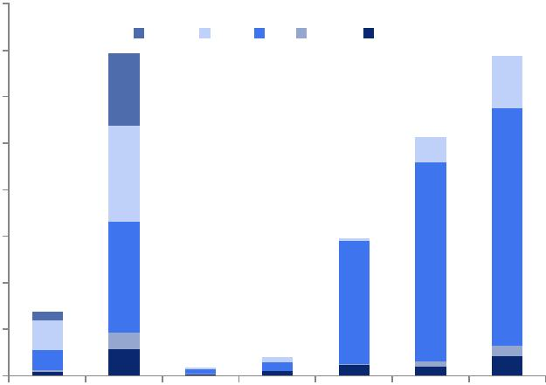
$160,000
Baa Ba B Caa NR
$140,000
$120,000
$100,000
$80,000
$60,000
$40,000
$20,000

$0

2006 | 2007 | 2009 | 2010 | 2011 | 2012 | 2013
Here are the facts
Overheating is evidently seen in the leveraged loan market where cov-lite loans have made a comeback over the past two years. The rating distribution across issuers has shifted lower and is presently more tilted towards B-rated issuers vs. BB-rated issuers as seen in 2005-2007 boom years. The trend shown in the chart above suggests that lending standards in leveraged loan market have turned too loose even judged by the standards of pre-crisis boom years. This is risk to the current benign environment in the high yield market. As witnessed in the last default cycle, cov-lite loan portfolios fared better than the broader market. Cov-lite loans provide issuers more room to maneuver compared to standard loans, more so during downturns.
CCC risk is overbought
Credit risk is overbought for CCC bonds. The Credit Risk Premium by Goldman Sachs shows that CCC bonds provide a smaller premium net of losses compared to BB or B bonds.
The misplaced concern
One misplaced concern is that new issue volumes are leveraging balance sheets. The record high new issue volumes have brought concern among some people that corporations, more so those in the high yield market, might be leveraging up their balance sheets a little too fast comparative to the rate of improvement of the boarder economy. There is little evidence from data from the primary bond and loan markets show low yield s are fuelling balance sheet releveraging.
Another misplaced concern is the view that a prolonged period of outflows from mutual funds would result in a fire sale in the secondary market. Well, that is not true since the ‘Great Rotation’ will likely skip the corporate bond bucket in fixed income. Even if the ‘Great Rotation’ materializes to cause a prolonged period of outflows from the corporate bond market, it will not put the performance of corporate bond portfolios at much risk. The conclusion is that for both equity and fixed income, the price impact of fund flows is negligible.
Significant outflows from fixed income mutual funds, more so those in the high yield, have caused many market participants to question that conclusion. Their argument is that low dealers’ inventory levels and poor secondary market liquidity may worsen the adverse effects from a lengthy period of selling pressure. This is simply not true. These worries are overdone.

